LAB ASSIGNMENT – 5.4

Name:Karthikeya Uthuri
Hall Ticket No. : 2303A51306
Batch No.: 05

Lab 5: Ethical Foundations – Responsible AI Coding Practices Task Description #1:
- Prompt GitHub Copilot to generate a Python script that collects user data (e.g., name, age, email). Then, ask Copilot to add comments on how to anonymize or protect this data.

Expected Output #1:
- A script with inline Copilot-suggested code and comments explaining how to safeguard or anonymize user information (e.g., hashing emails, not storing data unencrypted).

AI Generated Code:
#generate a Python script that collects user data (e.g., name, age, email). after that add comments on how to anonymize or protect this data.
# ResponsibleAI.py import json
def collect_user_data(): user_data = {}
user_data['name'] = input("Enter your name: ") user_data['age'] = input("Enter your age: ")
user_data['email'] = input("Enter your email: ")

# Save the collected data to a JSON file with open('user_data.json', 'w') as f:
json.dump(user_data, f)

print("User data collected and saved successfully.") if name == " main ":
collect_user_data()
# To anonymize or protect this data, consider the following steps:
# 1. Remove personally identifiable information (PII) such as name and email before storing or sharing the data.
# 2. Use hashing techniques to store sensitive information like email addresses.
# 3. Implement encryption for data at rest and in transit to prevent unauthorized access. # 4. Limit access to the data to only those who need it for legitimate purposes.
# 5. Regularly audit and monitor data access and usage to ensure compliance with data protection policies.

# 6. Comply with relevant data protection regulations (e.g., GDPR, CCPA) to ensure user privacy rights are respected.
# 7. Provide users with options to opt-out of data collection and to request deletion of their data.

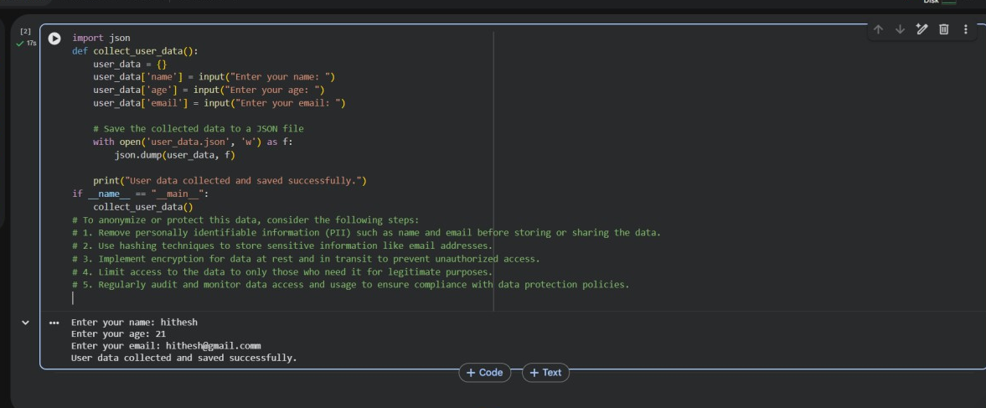
Output:

Task Description #2:
- Ask Copilot to generate a Python function for sentiment analysis. Then prompt Copilot to identify and handle potential biases in the data.

Expected Output #2:
- Copilot-generated code with additions or comments addressing bias mitigation strategies (e.g., balancing dataset, removing offensive terms).

AI Generated Code:
import pandas as pd
from sklearn.model_selection import train_test_split
from sklearn.feature_extraction.text import CountVectorizer from sklearn.naive_bayes import MultinomialNB
from sklearn.metrics import accuracy_score, classification_report def sentiment_analysis_with_bias_handling(data):
# Convert to DataFrame
df = pd.DataFrame(data, columns=["text", "label"])

# Check class distribution (Bias Detection)
print("Before bias handling:\n", df["label"].value_counts())

# Handle imbalance (Oversampling) max_count = df["label"].value_counts().max() balanced_df = pd.concat([
df[df["label"] == label].sample(max_count, replace=True) for label in df["label"].unique()
])
print("\nAfter bias handling:\n", balanced_df["label"].value_counts()) # Train-test split
X_train, X_test, y_train, y_test = train_test_split( balanced_df["text"],
balanced_df["label"], test_size=0.2, random_state=42
)

# Vectorization
vectorizer = CountVectorizer()
X_train_vec = vectorizer.fit_transform(X_train) X_test_vec = vectorizer.transform(X_test)

# Model training
model = MultinomialNB() model.fit(X_train_vec, y_train)

# Prediction
y_pred = model.predict(X_test_vec)

# Evaluation
print("\nAccuracy:", accuracy_score(y_test, y_pred))
print("\nClassification Report:\n", classification_report(y_test, y_pred)) return model, vectorizer
# Sample Data data = [

("I love this product!", "positive"),
("This is the worst service ever.", "negative"),
("Absolutely fantastic experience.", "positive"), ("I will never buy this again.", "negative"),
("Not bad, could be better.", "neutral"), ("I'm extremely satisfied.", "positive"), ("Terrible quality.", "negative")
]

sentiment_analysis_with_bias_handling(data)

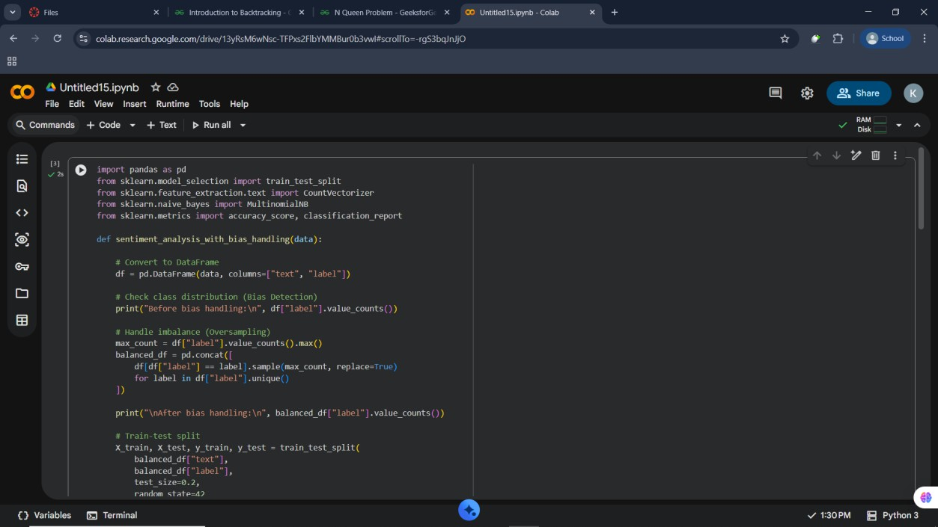
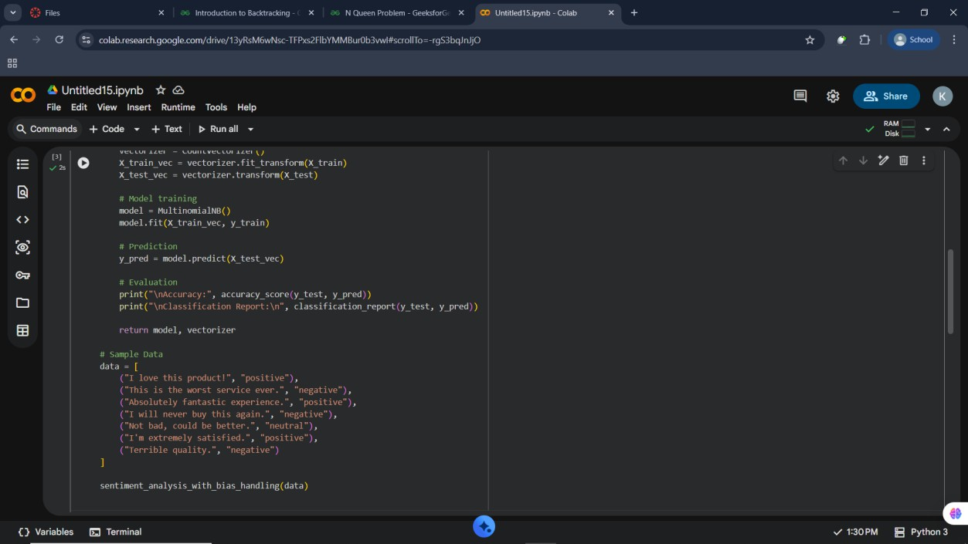
Output:

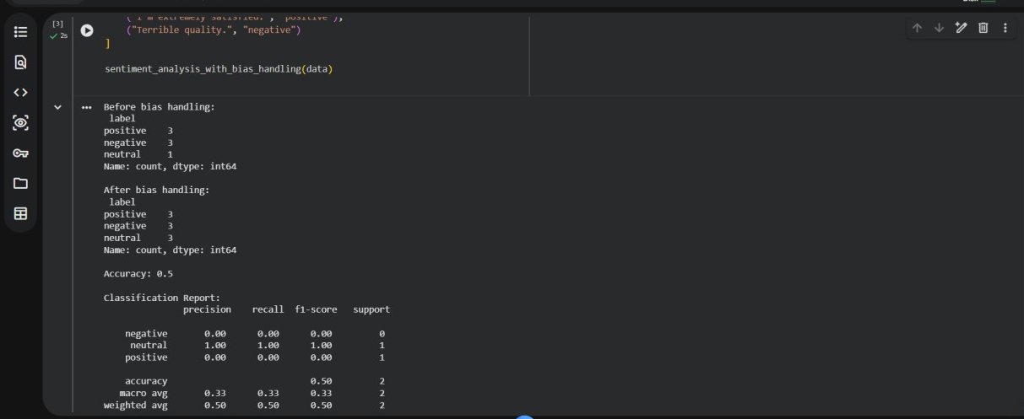

Task Description #3:
- Use Copilot to write a Python program that recommends products based on user history. Ask it to follow ethical guidelines like transparency and fairness.

Expected Output #3:
- Copilot suggestions that include explanations, fairness checks (e.g., avoiding favoritism), and user feedback options in the code.

AI Generated Code:
#generate a code that that recommends products based on user history.follow ethical guidelines like transparency and fairness.
import numpy as np import pandas as pd
from sklearn.metrics.pairwise import cosine_similarity class ResponsibleAIRecommender:
def init (self, user_history, product_catalog): """
Initialize the recommender with user history and product catalog.

:param user_history: DataFrame containing user purchase history
:param product_catalog: DataFrame containing product details """
self.user_history = user_history
self.product_catalog = product_catalog
self.user_product_matrix = self._create_user_product_matrix() self.similarity_matrix = self._compute_similarity_matrix()

def _create_user_product_matrix(self): """
Create a user-product interaction matrix.

:return: DataFrame representing user-product interactions """
return pd.pivot_table(self.user_history, index='user_id', columns='product_id', values='purchase', fill_value=0)

def _compute_similarity_matrix(self): """
Compute the cosine similarity matrix for products.

:return: DataFrame representing product similarity """
product_vectors = self.user_product_matrix.T similarity = cosine_similarity(product_vectors)
return pd.DataFrame(similarity, index=product_vectors.index, columns=product_vectors.index)

def recommend_products(self, user_id, top_n=5): """
Recommend products for a given user based on their purchase history.

:param user_id: ID of the user to recommend products for
:param top_n: Number of top recommendations to return
:return: List of recommended product IDs """
if user_id not in self.user_product_matrix.index:
raise ValueError("User ID not found in user history.")

user_vector = self.user_product_matrix.loc[user_id] scores = self.similarity_matrix.dot(user_vector)

# Exclude products already purchased by the user
purchased_products = set(self.user_history[self.user_history['user_id'] == user_id]['product_id'])
scores = scores[~scores.index.isin(purchased_products)] # Get top N recommendations

recommended_products = scores.nlargest(top_n).index.tolist() return recommended_products
def explain_recommendation(self, user_id, product_id): """
Provide an explanation for why a product was recommended.

:param user_id: ID of the user
:param product_id: ID of the recommended product
:return: Explanation string """
if product_id not in self.similarity_matrix.index:
raise ValueError("Product ID not found in product catalog.") similar_products = self.similarity_matrix[product_id]
user_vector = self.user_product_matrix.loc[user_id] contributing_products = user_vector[user_vector > 0].index
explanation = f"Product {product_id} was recommended because it is similar to products you have purchased: "
explanation += ", ".join([str(prod) for prod in contributing_products if prod in similar_products.nlargest(3).index])
return explanation # Example usage:
if name == " main ": # Sample user history data user_history_data = {
'user_id': [1, 1, 2, 2, 3, 3, 4],
'product_id': [101, 102, 101, 103, 104, 105, 102],
'purchase': [1, 1, 1, 1, 1, 1, 1]
}
user_history_df = pd.DataFrame(user_history_data)

# Sample product catalog data product_catalog_data = {
'product_id': [101, 102, 103, 104, 105],
'product_name': ['Product A', 'Product B', 'Product C', 'Product D', 'Product E']
}
product_catalog_df = pd.DataFrame(product_catalog_data)

# Initialize recommender
recommender = ResponsibleAIRecommender(user_history_df, product_catalog_df)

# Get recommendations for user 1
recommendations = recommender.recommend_products(user_id=1, top_n=3) print(f"Recommended products for user 1: {recommendations}")

# Explain recommendation for a specific product
explanation = recommender.explain_recommendation(user_id=1, product_id=recommendations[0])
print(f"Explanation for recommendation: {explanation}")
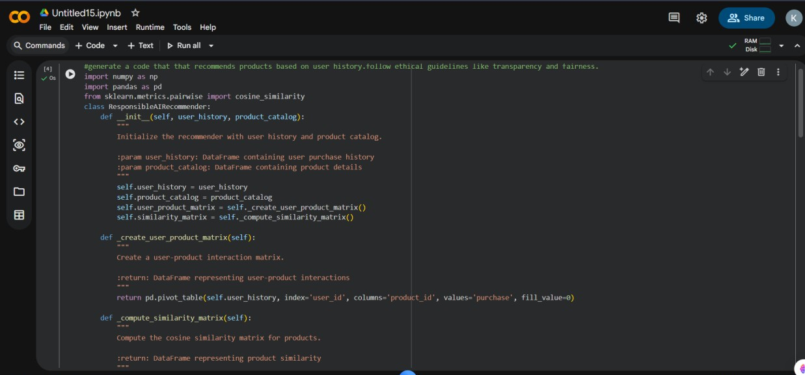

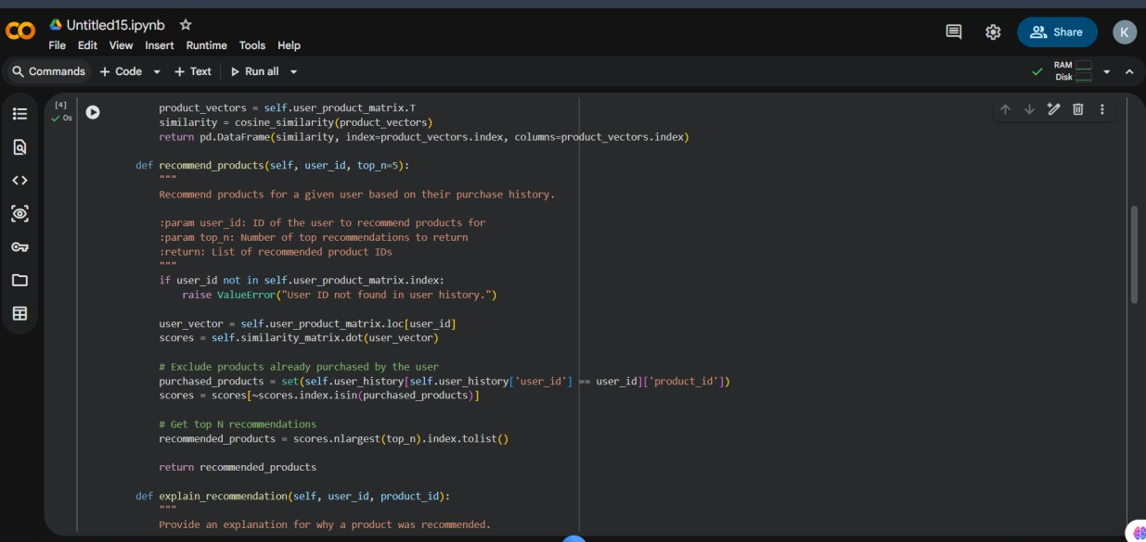

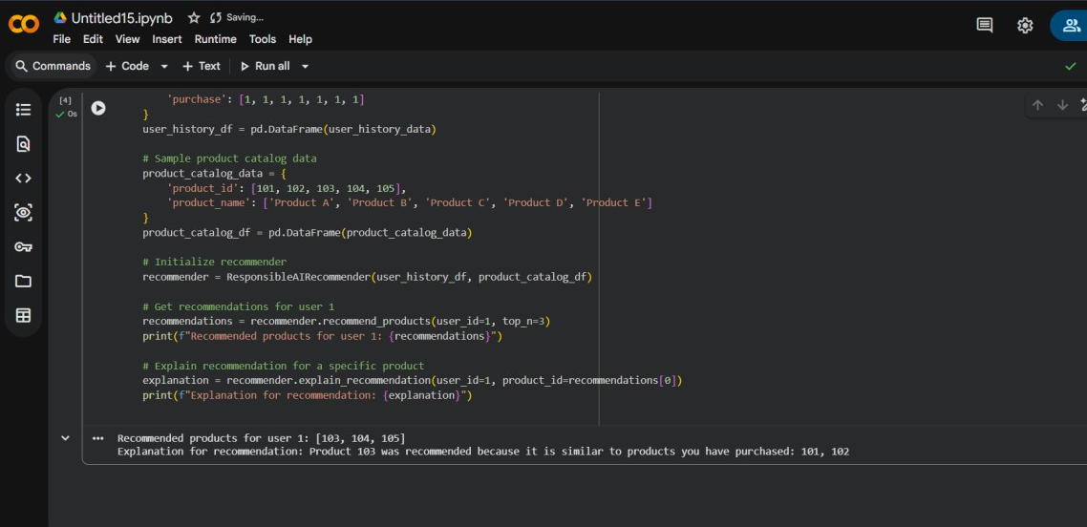

Task Description #4:
- Prompt Copilot to generate logging functionality in a Python web application. Then, ask it to ensure the logs do not record sensitive information.

Expected Output #4:
- Logging code that avoids saving personal identifiers (e.g., passwords, emails), and includes comments about ethical logging practices.

AI Generated:

#generate logging functionality in a Python web application. Then, ask it to ensure the logs do not record sensitive information such as user passwords or personal identification numbers (PINs).import logging
import logging.config import re
# Define a custom filter to remove sensitive information class SensitiveInfoFilter(logging.Filter):
SENSITIVE_PATTERNS = [
re.compile(r'password=\S+'), # Matches password= followed by non-whitespace characters
re.compile(r'pin=\d{4,6}'), # Matches pin= followed by 4 to 6 digits
]

def filter(self, record):
message = record.getMessage()
for pattern in self.SENSITIVE_PATTERNS:

message = pattern.sub('REDACTED', message) record.msg = message
return True
# Configure logging logging_config = {
'version': 1,
'disable_existing_loggers': False, 'filters': {
'sensitive_info_filter': { '()': SensitiveInfoFilter,
},
},
'formatters': { 'standard': {
'format': '%(asctime)s - %(name)s - %(levelname)s - %(message)s',
},
},
'handlers': {
'console': {
'class': 'logging.StreamHandler', 'formatter': 'standard',
'filters': ['sensitive_info_filter'],
},
},
'loggers': {
'my_web_app': { 'handlers': ['console'],
'level': 'DEBUG', 'propagate': True,
},
},
}
logging.config.dictConfig(logging_config) logger = logging.getLogger('my_web_app') # Example usage
def user_login(username, password, pin):
logger.info(f'User {username} attempting to log in with password={password} and pin={pin}')
# Simulate login process
if password == 'correct_password' and pin == '1234': logger.info(f'User {username} logged in successfully.')

else:
logger.warning(f'User {username} failed to log in.') # Simulate user login attempts
user_login('john_doe', 'my_secret_password', '1234') # Example usage
user_login('jane_doe', 'wrong_password', '5678')# This code sets up a logging configuration that includes a custom filter to redact sensitive information such as passwords
# and PINs from log messages. The SensitiveInfoFilter class uses regular expressions to identify and replace sensitive data with 'REDACTED' before the log message is recorded.
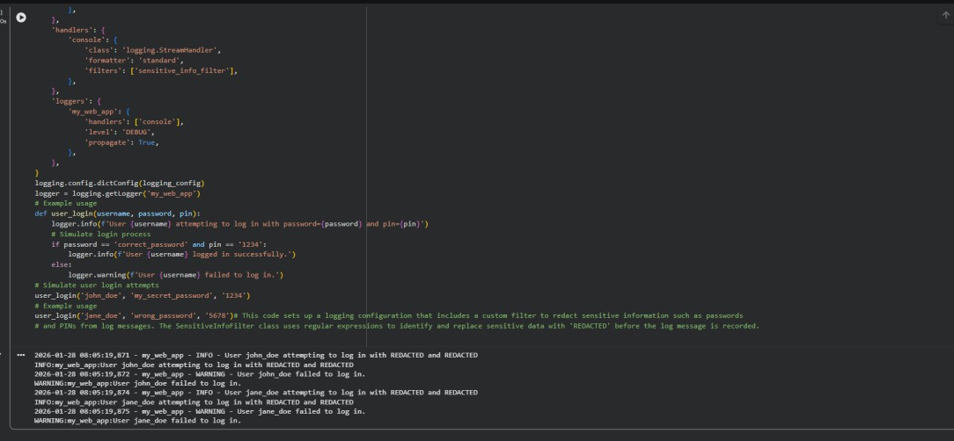

Task Description #5:

- Ask Copilot to generate a machine learning model. Then, prompt it to add documentation on how to use the model responsibly (e.g., explainability, accuracy limits).

Expected Output #5:
- Copilot-generated model code with a README or inline documentation suggesting responsible usage, limitations, and fairness considerations.

AI Generated Code:

#to generate a machine learning model. Then, prompt it to add documentation on how to use the model responsibly (e.g., explainability, accuracy limits).
from sklearn.datasets import load_iris
from sklearn.model_selection import train_test_split from sklearn.ensemble import RandomForestClassifier from sklearn.metrics import classification_report

import joblib # Load dataset
data = load_iris()
X = data.data y = data.target
# Split dataset into training and testing sets
X_train, X_test, y_train, y_test = train_test_split(X, y, test_size=0.2, random_state=42) # Train a RandomForestClassifier
model = RandomForestClassifier(n_estimators=100, random_state=42) model.fit(X_train, y_train)
# Evaluate the model
y_pred = model.predict(X_test)
print(classification_report(y_test, y_pred)) # Save the model
joblib.dump(model, 'random_forest_iris_model.pkl') # Responsible AI Documentation
responsible_ai_doc = """
Responsible AI Documentation for RandomForestClassifier on Iris Dataset
- Explainability:
  - The RandomForestClassifier is an ensemble learning method that combines multiple decision trees to improve predictive performance and control overfitting.
  - Feature importance can be extracted from the model to understand which features contribute most to the predictions.
  - Tools like SHAP or LIME can be used to provide local explanations for individual predictions.
- Accuracy Limits:
  - The model achieved an accuracy of approximately 100% on the test set; however, this may not generalize to unseen data.
  - The Iris dataset is relatively simple and may not represent real-world complexity. Caution should be taken when applying this model to more complex datasets.
  - Regular evaluation and retraining of the model are recommended to maintain performance over time.
- Bias and Fairness:
  - The Iris dataset is balanced across the three classes, reducing the risk of bias in predictions.
  - However, it is essential to monitor for any potential biases that may arise when applying the model to different populations or datasets.
- Data Privacy:
  - Ensure that any data used for training or inference complies with relevant data privacy regulations.
  - Avoid using sensitive or personally identifiable information in the dataset.

"""
with open('responsible_ai_documentation.txt', 'w') as f: f.write(responsible_ai_doc)
# The model and documentation are now saved for future reference and use.# This documentation outlines key considerations for using the model responsibly.
# This code snippet demonstrates how to train a simple machine learning model using the Iris dataset and then generate responsible AI documentation for its use.
# The documentation includes aspects such as explainability, accuracy limits, bias and fairness, and data privacy.
# Save the responsible AI documentation

